Group 13 Model Rocket Design Project
Andrew J. Prokash and Leon H. Zheng¹ and Jasper S. Scott¹ and Jack C. Martin¹

Daniel Guggenheim School of Aerospace Engineering, Atlanta, Georgia, 30332
We were given a goal of modifying a model rocket to hold a Pnut altimeter, and launching it as close to 125 ft in the air as possible. To complete our goal, we could only use 3D printed components and laser cut wood. We needed multiple design iterations to perfect our payload bay, nose cone, and transition piece dimensions. We also had multiple iterations of fins, cut from birch plywood, in order to improve static stability. Our design weighed 52.2 grams and had a stability of 1.94 calibers. During our first launch, we had a faulty altimeter that did not record our apogee or flight profile. On our second attempt, our rocket achieved a final apogee of 160 ft. When the ejection charge fired the second time, our rocket broke in multiple places, which clearly emphasized that the rocket did not have enough strength to hold a second round of force from the charge. Possible reasons for the rocket going so high over the target apogee includes less drag than predicted in OpenRocket, an increase in motor performance than nominal specifications, and weather constraints not input into OpenRocket simulation. In the future, we could add a third static canard for increased stability and add more weight through padding for the altimeter or more weight to decrease apogee.

Nomenclature
C_{g} = center of gravity
C_{p} = center of pressure
c.m. = center of mass
m = mass
ft = feet
cal = calibers

Introduction
This is our write-up for our rocket project for AE 1601, Intro to Aerospace Engineering. In this project, we were given an Estes Wizard rocket with an A8-3 engine to modify to fit a Pnut altimeter. We had to modify it to reach a target height of 125 ft using only 3d printed parts from the Aero Maker Space (AMS), and laser cut plywood, also from the AMS. While none of us have used Open Rocket or SolidWorks, everyone in our group has some experience in using a CAD software. This paper covers how we chose our engine, and all of the design modifications we made and the process behind them. It then details how our flight went, and what went differently from the open rocket simulation.

Model Rocket Kit Selection
We were given two different options in terms of what engine we would be allowed to put in our rocket. We input the specification for a base Estes Wizard rocket and realized that to get to the minimum of 50 feet, we would need to use the A8-3 engine, as opposed to the 1/2A6-2, because the engine provided double the impulse and more thrust.

General Overview of the Design Modification
Our modified rocket has a max length of 36 cm, with a maximum diameter of 2.2 cm. The total mass in Open Rocket is 52.2g with the motor. The widest section of our rocket is the payload bay, to hold the altimeter. The payload bay has 2 canards in order to reduce stability to our rocket because we had too much stability without the canards. We cut the body tube from 22 cm to 18 cm to comply with our OpenRocket design for stability reasons. The payload bay diameter was larger than the body tube in order to comfortably fit the altimeter. We also added 3 fins to the base of the rocket, which greatly increases stability when the rocket gets launched. There is negligible mass as padding for our altimeter, and we had some recovery wadding close to the engine charge, shifting the C_{g} backward. Our engine block was placed a quarter inch further back than expected due to errors in assembly, but that didn’t impact stability or mass much. The engine fit tightly and we added one ring of tape around the outside of the engine to provide a very strong friction fit to prevent the engine from coming loose during flight.

Weight and Balance
Our measured weight in OpenRocket was 52.2 grams, including the engine and Pnut altimeter. When we measured our rocket with the scale on launch day, the rocket was measured at 52 grams, which is accurate to our OpenRocket diagram. Our calculated C_{m} from OpenRocket was at 22.3 cm.
Description of weight components | Mass | Location of weight components | Impact on the center of mass
Body Tube | 3.56 grams | The whole bottom part of the rocket | Holds everything else
Motor | 13.9 grams | Right at the bottom of the rocket | Moves the c.m. lower by 3.1 cm
Nose Cone | 4.89 grams | The very top of the rocket | Moves the c.m. higher up by 6.8 cm
Pnut Altimeter | 7.3 grams | In the payload bay, slightly above the mid-point of the rocket. | Moves the c.m. higher up by 1.5 cm
Streamer | 1.34 grams | Very near the middle of the rocket | Moves the c.m. higher by 0.1 cm
Fins | 6.55 grams | At the bottom of the rocket | Moves the c.m. lower by 1.5 cm.
Canards | 0.956 grams | On the payload bay | Moved the c.m. up by 0.2 cm.
Shock Cord | 0.893 grams | Directly below the streamer | Does not change c.m.
Recovery Wadding | 1.5 grams | Directly below shock cord | Moves the c.m. down by less than 0.1 cm.
Payload Bay | 7.01 grams | Mounted above the body tube. | Moves the c.m. higher up the rocket by 3 cm.
Transition Piece | 1.19 grams | Between the body tube and payload bay. | Moves the c.m. up by 0.4 cm.
Engine Block | 0.865 grams | Directly above the engine | Moves the c.m. down by 0.1 cm
Launch Lug | 0.271 grams | Mounted on the payload bay, between the canards | Moves the c.m. up by 0.1 cm.
Altimeter Padding | 1 gram | In between the altimeter and the payload bay walls. | Moves the c.m. up by 0.2 cm
Nose Cone Insert | 1 gram | Mounted to the transition piece, in the body tube. | Moves the c.m. up by 0.1 cm.

Design Modification Process
Firstly, we put in the required components into OpenRocket: nose cone, payload bay, punt altimeter, recovery system, engine, and fins. Then, we looked into the optimal design of our fins to make sure that it can add stability to our rocket, so it is stable during flight. Since our stability was too high, we decided to add static canards to the payload bay using the same fin shape as the fins to shift the center of pressure forward, causing our stability to be within the 1-2 cal range. We also optimized the nose cone for less drag to optimize the rocket’s flight trajectory. Then, since we were still sitting a little above the target apogee of 125 ft, we added cushioning to the payload bay to bring our stability to 1.94 cal. We originally planned on having a parachute for our recovery system because our landing velocity was around 50 ft/s, but then we switched to the provided streamer in the rocket kit to reduce the drift experienced by the rocket on landing. Also, the impact would not have had enough force to destroy the rocket, so we decided to remove the parachute and use the streamer instead. After receiving our first set of prints, the nose cone dimensions were what we wanted. However, our payload bay and transition to the body tube were double the radius that we wanted, so we needed to reprint after making the correct design modification in SolidWorks. On our second set of prints, the transition piece and payload bay came in much closer to where we wanted. We still needed to sand down the payload bay and nose cone to have them fit together. During our design review, we had some slight modifications to make. We had to add some larger holes in our payload bay, and add a floor to our transition piece, which we were already planning on doing. For our final print, all our components came out how we expected them to. We were able to fit everything together and assemble the rocket nicely. During the actual manufacturing part of the rocket, we planned on using balsa wood for our canards, but that was too fragile for the laser cutter, so we decided to use birch plywood instead to hold up better. Besides that, we were able to stick to our planned design without needing to make changes due to manufacturing or assembly issues.

Test and Evaluation
During the first launch, the rocket launched a visually estimated apogee of 120-140ft. The ejection charge fired after the rocket had reached its apogee but had no effect on the integrity of the components. The altimeter confirmed apogee was not saved within the altimeter, likely the result of wadding paper obstructing the airholes within the payload bay or a faulty altimeter. The faulty altimeter was the most likely situation, as other teams also had the same problems with their altimeters. As the overall structure of the rocket remained intact, a second launch was allowed with a new altimeter to mitigate the issue of a faulty altimeter. Then, less wadding paper was included in the payload bay to prevent the obstruction of the air holes. During the second launch, the apogee visually seemed much higher, and the airtime was beyond expectations. As the ejection charge ignited soon after the apogee, the rocket separated into four pieces: body, streamer, altimeter, and payload bay with nose cone. Without the streamer, most pieces succumbed to the full force of gravity but were not further damaged proving the integrity of our manufacturing and materials. Upon further inspection, the failure point was revealed to be between the transition piece and payload bay which were printed together, not the superglue connection between them. Therefore, the ejection charge placed enough strain to cleanly fractured the piece separately. The altimeter revealed the true apogee as 160ft, 35ft over the targeted apogee of 125ft. The difference in altitudes may have been the result of further upward velocity of the altimeter after ejection charge ignition and rocket separation, motor performance was higher than nominal specifications, and drag was lower than OpenRocket presumed.
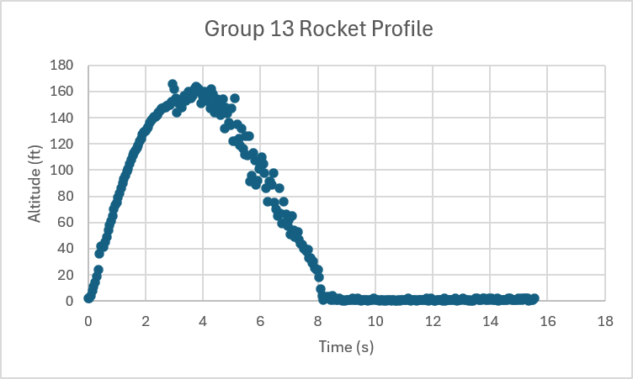

Conclusion and Recommendations for Further Design Improvements
OpenRocket ultimately greatly underestimated our real apogee, with its guess of 125 ft being 35 ft less than the experimental value of 160 ft. The rocket was weighed prior to the launch, and the weight was found to be 52 g, which is within a quarter of a gram of the estimated mass in OpenRocket of 52.225 g, indicating that a discrepancy in mass was not the cause of the error. We can therefore infer the difference can be ascribed to either environmental factors, such as lower drag than anticipated, that actual motor performance was higher than anticipated, or the altimeter getting extra height after the payload bay failed, and the altimeter getting a boost from the ejection charge. In the future we would increase stability by adding an extra canard to minimize tilt and increase the weight of the rocket by adding padding or other heavier weights such as washers to decrease apogee.

Appendix
Figure A-1:
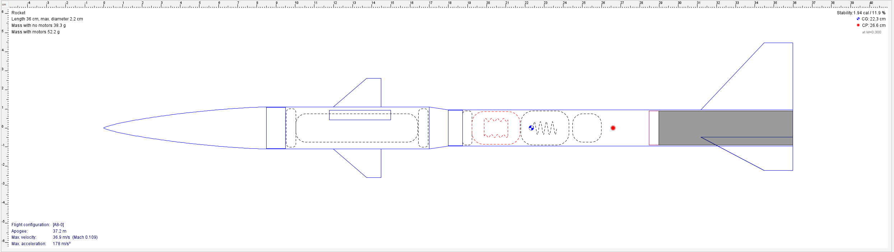

Acknowledgments
Thank you, Rita, our TA, for getting us a second body tube when we messed up. Thank you, Dr. Zaidi for teaching us all year, and also for allowing us to go again after our altimeter didn’t measure. Thank you to Michael and Sabina for helping out on rocket launch day. Lastly, thank you to the AMS mentors for getting all of our prints and helping us cut all of our fins.

References
1. Gasmire, C., "Model Rocket Fins 101: Purpose, Shape, Size, and Placement," The Model Rocket, 2026, https://themodelrocket.com.
This reference provided guidance on fin geometry and aerodynamic performance. Based on the stability and efficiency characteristics discussed, a clipped delta fin configuration was selected for the rocket design due to its favorable balance of aerodynamic efficiency and flight stability.
2. Hennin, B., "Why Should You Airfoil Your Fins?" Peak-of-Flight Newsletter, Apogee Components, Inc., No. 305, Jan. 2012, pp. 2–15, https://apogeerockets.com.
This source offered detailed design recommendations for clipped delta fins, including geometric proportions and aspect ratio considerations. These guidelines were used to establish the fin dimensions and overall fin planform for the final design.
3. Gasmire, C., "The Essential Guide to Model Rocket Nose Cones," The Model Rocket, 2026, https://themodelrocket.com.
Information from this reference was used to evaluate nose cone profiles for subsonic flight. A Van Haack nose cone was selected because it provides low aerodynamic drag and is well suited to the anticipated flight profile of the rocket.
4. "Launch Lug Location," Rocketry Forum, https://rocketryforum.com.
This resource informed the placement of the launch lug. The launch lug was positioned on the payload bay to guide the rocket smoothly off the launch platform, while also shifting the center of gravity forward just a little bit to add more stability.
5. Anderson, S. B., "A Look at Handling Qualities of Canard Configurations," NASA TM-88354, Sept. 1986, https://nasa.gov.
This reference provided insight into the aerodynamic effects of canard surfaces. Static canards were incorporated into the payload section to reduce the rocket's stability margin from approximately 3.7 calibers to 1.77 calibers, bringing the design into a more desirable stability range. Additionally, the added mass of the canards contributed to lowering the predicted apogee from approximately 210 ft to 187 ft, helping the rocket meet mission constraints better.

Undergraduate Student, Aerospace Engineering, J Erskine Love Manufacturing Building Room 185.

